

Faculty of APPLIED & computer sciences

Computer science DEPARTMENT

**BUSINESS ANALYSIS 2.2 - (AIBTY2A /AIFYT2A)**

**GROUP ASSIGNMENT**

**NAME OF BUSINESS: CHOCOLATE RUSH**

|  |  |  |
| --- | --- | --- |
| Student Number | Surname | Initials |
| 223215031 | Leshilo | B |
| 223622818 | Rakobela | SG |
| 221987223 | Thobejane | MK |
| 222615389 | Baloyi | CA |
| 223112577 | Mbubana | M |
| 224056107 | Maahlo | V |

**Submission date: 25 October 2024**

**RE-SUBMISSION DATE: 26 October - 1 November 2024**

**Table of Contents**1. Description of the business..................................................................3

2. Description of the process…………………………………………………3

Sales & Collection process...............................................................3

Acquisition & Payment process........................................................3

Conversion process..........................................................................4

3. REA DIAGRAMS……………………………………………………………4

Sales & Collection Process...............................................................5

Acquisition & Payment process.........................................................5

Conversion process............................................................................6

4. Possible information needs…………………………………………….…..7

Sales & Collection Process...............................................................7

Acquisition & Payment Process........................................................8

Conversion Process ........................................................................8

5. Tables with data added .........................................................................9

Sales & Collection Process .............................................................9

Acquisition & Payment Process......................................................10

Conversion Process........................................................................11

6. Integrated REA Diagram.......................................................................12

7. Integration problems ............................................................................13

8. Referencces..........................................................................................16

1. **Description of the business**

The Chocolate Rush is an artisan chocolate company aspiring to offer high-quality, decently sourced chocolate for every chocolate lover in the world. Chocolate Rush is ready to nail a niche within the luxury chocolate market through creativity, sustainability, and healthy ingredients combined into quality products. This range of chocolates includes dark, milk, and specialty chocolate products and would help assorted kinds of consumers have their indulgent experiences with a sustainable and responsible impact.

1. **Description of the process  
     
   Sales &collection process**

**Description:** This process involves managing the sales and distribution of chocolates to customers, which includes direct consumers, retailers, and wholesalers. The process tracks customer orders, manages sales transactions, generates invoices, and records payments.

**Database Design**: For the Sales & Collection process, you would need tables to store information about:  
 Customers: Stores customer details like name, contact, and address.  
 Orders: Contains order information, including order ID, customer ID, order date, and status.

Products: Holds product details like product ID, name, type (dark, milk, specialty), and price.

Invoices: Links orders to invoices, capturing invoice details, amounts, and payment status.

Payment Records: Tracks payment methods, amounts, payment dates, and references to invoices.  
 Sales Transactions: Tracks transaction details, including product types, quantities, and amounts.

**Acquisition & Payment Process**

* **Description:** This process manages the procurement of cocoa beans, packaging materials, and other ingredients required for chocolate production. It includes recording purchase orders, managing supplier relationships, and tracking payments.
* **Database Design**: For the acquisition and payment process, you would need tables to store information about:  
  Suppliers: Holds supplier information, including supplier ID, name, and contact.  
  Purchase Orders: Represents orders for raw materials from suppliers.  
  Raw Materials: Contains raw material details like name, type, unit cost, and quantity available.  
  Supplier Payments: Tracks payments made to suppliers, including payment date and method.  
  Inventory: Manages stock levels for raw materials used in production.

**Conversion Process**

* **Description:** The conversion process involves transforming raw materials like cocoa beans into finished chocolate products. This process includes managing production schedules, tracking work-in-progress, and quality control to ensure consistency and flavour.
* **Database Design:** To support the Conversion process, you would need tables to manage:  
  Production Schedules: Manages production timelines (schedule ID, product type, start and end dates).  
  Work Orders: Tracks details of each production run (work order ID, production schedule ID, materials used).  
  Inventory: Monitors raw materials and finished goods (product ID, type, quantity produced).  
  Quality Control Records: Documents quality checks and inspection results (QC ID, product ID, inspection date, results).  
    
  **3. REA DIAGRAMS  
  Sales & collection process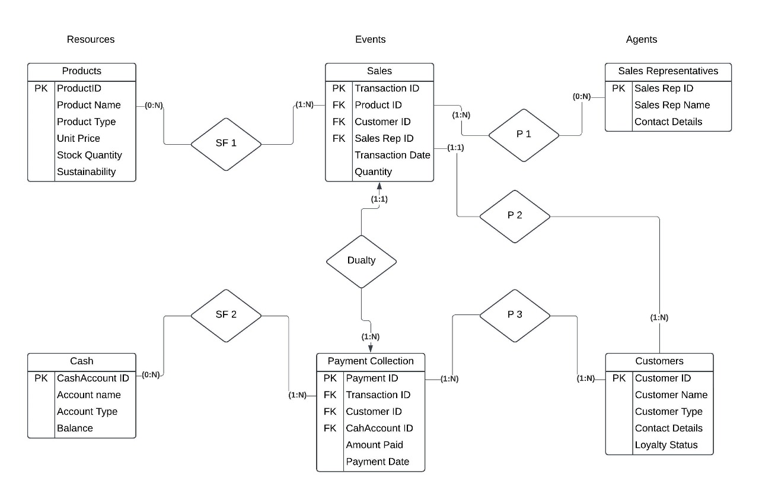 Acquisition & Payment Process**

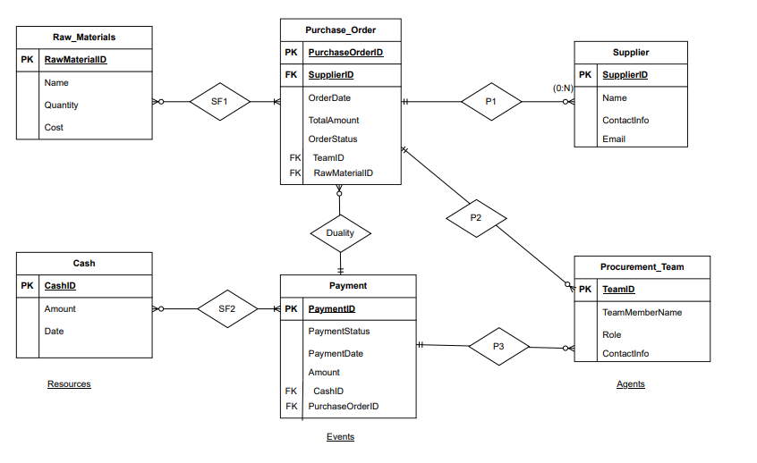

**Conversion Process**

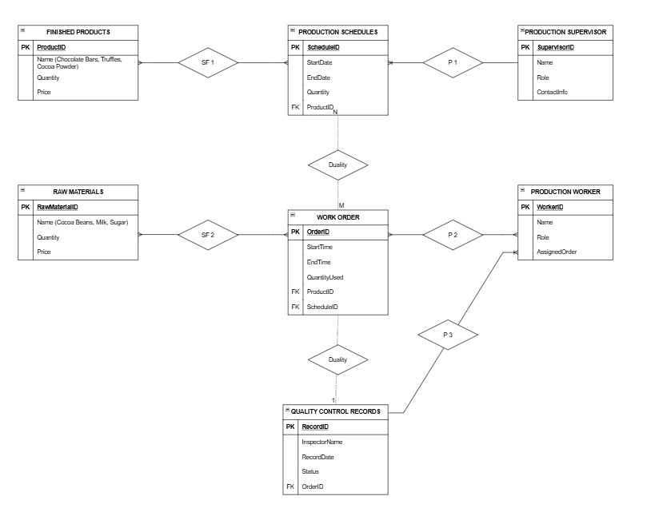

* 1. **Possible information needs**

**Sales & collection process**

* **Sales Summary Report:** It displays the trend of sales products by product type, date, and customer segment: direct consumers, retailers, and wholesalers. This report forms the basis for identifying top-selling products and peak sale periods.
* **Customer Order History Report:** It gives the order history of each customer regarding the status of the products purchased, the date, quantity, and amount of money spent in total. This report helps in the management of customer relationships and personalized marketing**.**
* **Aged Receivables Report:** Monitors accounts receivable and identifies each by age bracket, including 0-30 days, 31-60 days, etc., in the management of past-due accounts to ensure improved cash flow.
* **Product Demand Forecasting Report:** Analyzes historical sales data to predict demand forecasting of each type of chocolate that will help the production planning and inventory management.
* **Sales Performance Report by Sales Channel**: Allows the comparison of sales performances across direct, retail, and wholesale channels to pinpoint which channels are more profitable and focus marketing effort on that realization.

**Acquisition & Payment Process**

* **Supplier Performance Report:** Evaluates each supplier based on approximate delivery time, material quality, and pricing to better manage the relationship with suppliers or take better sourcing decisions.
* **Purchase Order Report:** Lists all open and fulfilled purchase orders, quantities, costs, and suppliers. This report is developed to manage procurement activities for timely material availability.
* **Inventory Reorder Report:** Schedules and maintains raw materials' inventory levels through initiating action/reorder alerts during quantity levels below defined threshold quantities needed for sustaining production.
* **Payment Aging Report:** Provides a summary of the outstanding payable to suppliers, sorted in order of age in order to manage and prioritize cash outflows efficiently.
* **Cost of Raw Materials Report:** Monitors the cost of cocoa, packaging, and all other materials over time to study the cost trend analysis in budget control.

**Conversion Process**

* **Production Schedule Report:** This report lists current batches in production, inclusive of start and planned completion dates, to assist in resource planning and useful scheduling.
* **Work-in-Progress Report:** The WIP report keeps records of all production orders in current process. It shows raw material usage, labor input, machine time utilized, which becomes very helpful for monitoring productivity and progress.
* **Quality Control Report:** This would specify the results of quality inspections for several batches, pointing out problems or reworks required. A report to testify to the consistency in the quality finished chocolate products.
* **Finished Goods Inventory Report:** This provides the quantities of chocolate products completed and assists in the management of inventories, putting them on sale.
* **Productivity Efficiency Report:** The report consists of the efficiency of resource utilization involving labor, machine, and material usage in each production cycle by underlining ways of cost optimization and process improvement.

**5.Tables with data added**

**Sales & collection process**

**Customers Table:**

|  |  |  |  |
| --- | --- | --- | --- |
| CustomerID | Customer_Name | Segment | Contact_Info |
| C001 | Alice Johnson | Direct | alicej@gmail.com |
| C002 | Chocolate Ltd. | Retailer | Chocolate1@gmail.com |
| C003 | Sweet Treats | Wholesaler | sweettreats@gmail.com |

**Product Table:**

|  |  |  |  |
| --- | --- | --- | --- |
| ProductID | Product_Name | Category | UnitPrice |
| P001 | Dark Chocolate | Chocolate Bar | R44,50 |
| P002 | Milk Chocolate | Chocolate Bar | R53.04 |
| P003 | White Chocolate | Chocolate Bar | R48,62 |

**Invoices Table:**

|  |  |  |  |  |  |
| --- | --- | --- | --- | --- | --- |
| InvoiceID | OrderID | CustomerID | Invoice_Date | Amount_Due | Status |
| INV001 | O001 | C001 | 2024-10-21 | R442,00 | Paid |
| INV002 | O002 | C002 | 2024-10-22 | R1060,80 | Pending |
| INV003 | O003 | C003 | 2024-10-23 | R729,30 | Paid |

**Sales Transactions Table:**

|  |  |  |  |  |  |
| --- | --- | --- | --- | --- | --- |
| TransactionID | OrderID | ProductID | Quantity | Unit_Price | Total_Amount |
| T001 | O001 | P001 | 10 | R44,50 | R445,00 |
| T002 | O002 | P002 | 20 | R53,04 | R1060,80 |
| T003 | O003 | P003 | 15 | R48,62 | R729,30 |

**Orders Table:**

|  |  |  |  |
| --- | --- | --- | --- |
| OrderID | CustomerID | Order_Date | Order_Status |
| O001 | C001 | 2024-10-20 | Shipped |
| O002 | C002 | 2024-10-21 | Processing |
| O003 | C003 | 2024-10-22 | Delivered |

**Payment Records Table:**

|  |  |  |  |  |  |
| --- | --- | --- | --- | --- | --- |
| Payment_D | InvoiceID | CustomerID | PaymentDate | Amount_Paid | Payment_Method |
| PMT001 | INV001 | C001 | 2024-10-22 | R445,00 | Credit Card |
| PMT002 | INV003 | C003 | 2024-10-24 | R729,30 | Bank Transfer |

**Acquisition & payment process**

**Supplier Table**

|  |  |  |  |
| --- | --- | --- | --- |
| SupplierID | Supplier_Name | Contact_Info | Rating |
| S001 | Cocoa Corp | contact@cocoacorp.com | 4.5 |
| S002 | SweetPack | sales@sweetpack.com | 4.8 |
| S003 | Sugar Source | info@sugarsource.com | 4.2 |

**Purchase Order Table**

|  |  |  |  |  |
| --- | --- | --- | --- | --- |
| PurchaseOrderID | SupplierID | Order_Date | Expected_Delivery | Status |
| PO001 | S001 | 2024-10-10 | 2024-10-17 | Received |
| PO002 | S002 | 2024-10-11 | 2024-10-18 | Pending |
| PO003 | S003 | 2024-10-15 | 2024-10-22 | In Transit |

**Raw Material Table**

|  |  |  |  |  |
| --- | --- | --- | --- | --- |
| RawMaterialID | Material_Name | SupplierID | Unit_Cost | Stock_Quantity |
| RM001 | Cocoa Beans | S001 | R35/kg | 500 kg |
| RM002 | Sugar | S003 | R20/kg | 200 kg |
| RM003 | Packaging | S002 | R15/unit | 1000 kg |

**Supplier Payments Table**

|  |  |  |  |  |  |
| --- | --- | --- | --- | --- | --- |
| PaymentID | PurchaseOrderID | SupplierID | Payment_Date | Amount_Paid | Status |
| PAY001 | PO001 | S001 | 2024-10-18 | R4000 | Completed |
| PAY002 | PO003 | S003 | 2024-10-23 | R1800 | Pending |

**Inventory Table**

|  |  |  |  |
| --- | --- | --- | --- |
| InventoryID | RawMaterialID | Current_Stock | Last_Updated |
| INV001 | RM001 | 300 kg | 2024-10-20 |
| INV002 | RM002 | 100 kg | 2024-10-20 |
| INV003 | RM003 | 800 units | 2024-10-20 |

**Conversion Process**

**Production Schedules Table**

|  |  |  |  |  |
| --- | --- | --- | --- | --- |
| ScheduleID | ProductID | Start_Date | Planned_Completion | Status |
| PS001 | P001 | 2024-10-25 | 2024-10-27 | In Process |
| PS002 | P002 | 2024-10-26 | 2024-10-28 | Scheduled |
| PS003 | P003 | 2024-10-27 | 2024-10-29 | Not Started |

**Work Orders Table**

|  |  |  |  |  |
| --- | --- | --- | --- | --- |
| OrderID | ScheduleID | RawMaterialID | Quantity_Required | Status |
| WO001 | PS001 | RM001 | 100 kg | In Progress |
| WO002 | PS002 | RM002 | 50 kg | In Progress |
| WO003 | PS003 | RM003 | 300 units | Pending |

**Quality Control Records Table**

|  |  |  |  |  |
| --- | --- | --- | --- | --- |
| RecordID | ProductID | RecordDate | Status | InspectorName |
| QC001 | P001 | 2024-10-28 | Pass | John Smith |
| QC002 | P002 | 2024-10-29 | Rework | Emily Clark |
| QC003 | P003 | 2024-10-30 | Pending | Mark White |

**Finished Goods Inventory Table**

|  |  |  |  |
| --- | --- | --- | --- |
| Finished_Goods_ID | ProductID | Quantity | Last_Updated |
| FG001 | P001 | 150 units | 2024-10-28 |
| FG002 | P002 | 100 units | 2024-10-29 |
| FG003 | P003 | 200 units | 2024-10-30 |

**Productivity Efficiency Report Table**

|  |  |  |  |  |  |
| --- | --- | --- | --- | --- | --- |
| Report_ID | ScheduleID | Labor_Hours | Machine_Hours | Material_Used | Efficiency_Score |
| PE001 | PS001 | 30 hrs | 15 hrs | 100 kg | 92% |
| PE002 | PS002 | 25 hrs | 10 hrs | 80 kg | 88% |
| PE003 | PS003 | 20 hrs | 8 hrs | 75 kg | 90% |

**6. Integrated REA Diagram**

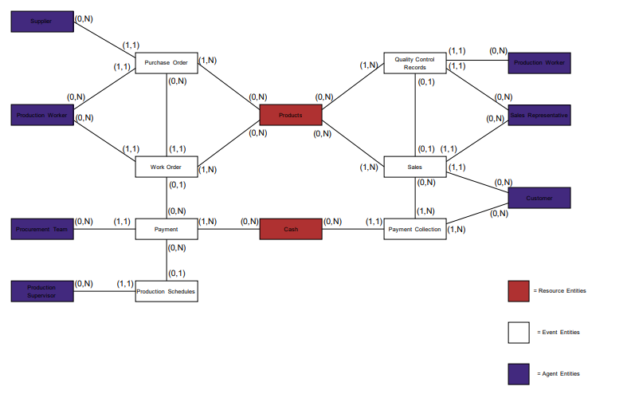

**7. Integration problems**

* **Data Inconsistencies**

**Problem:** Incongruence of data due to different formats being maintained by different departments. For example, product names might be maintained differently in sales and production, resulting in incongruence when reports are pulled out.  
**Solution:** Standardize a common data model. Introduce a cleaning process of the data. An ERP system will be provided that will enforce naming conventions and accurate data representation across all departments.

* **Incompatible Systems**

**Problem:** Incompatible systems are in place for different departments. For instance, sales could be using cloud-based software, while procurement uses older software that doesn't necessarily support APIs.   
**Solution:** This is possible with the help of middleware or iPaaS tools, enabling the exchange of data between systems. Introduce APIs and ETL processes to bridge these systems or upgrade the legacy systems for better compatibility.

* **Real-time data synchronization**

**Problem:** Real-time data cannot be synchronized, which impacts decision-making in a way that may lead to problems such as orders not being delivered on time.

**Solution:** Event-driven architecture can be one of the best options; utilizing message brokers like RabbitMQ or Kafka will provide near real-time updates between systems. Real-time dashboards will also support timely decisions.

* **Redundant or Overlapping Data**  
  **Problem:** Redundancy is said to occur when copies of the same data item are stored across different departments, as would occur if several departments such as Sales and Inventory maintain their own copies of quantities of products on hand. This, in turn, fosters errors amidst data. **Solution:** Implement Centralized Master Data Management System and keep the same as a Single Version of Truth. Auditing of data to identify duplication of records and eliminate the same regularly.
* **Integration with other Departmental Workflows**

**Problem:** Inefficient workflow between departments, such as not informing the production department in good time upon the arrival of huge sales orders; similarly, failure to inform procurement upon realization of a raw material shortage.

**Solution:** Automate workflows through ERP or automation of processes. Alerts may then be set up once certain thresholds are reached threshold number of sales orders for example, ensuring smooth coordination.

* **User Training and Adoption**  
  **Problem:** It is also problematic because employees cannot manage the new systems and processes as well, and they often are resistant to them, simply because of their unfamiliarity with new tools and processes.  
  **Solution:** Provide thorough training, straightforward documentation, and hands-on workshops.

**References**<https://en.wikipedia.org/wiki/Chocolate>  
https://www.youtube.com/watch?v=7lvSgsqdBhM